**BEATING FAMINE IN THE SAHEL**

**CONFERENCE DECLARATION**

1. **We, the 561 participants representing inter-governmental organizations, 30 African countries, ministerial departments, local government institutions, regional agencies, international organizations, many national non-govermental organizations, farmers’, womens’ and other civil society organizations, the private sector, research organizations and universities** gathered together in Bamako, Mali, at the Beating Famine Conference in the Sahel, from 26-28 February, 2019.
2. **We noted that the long-term trends in land degradation, and the effects of climate change in the Sahel have reached a crisis state. This requires urgent and focused action** to scale-up land restoration, climate change adaptation, and regreening initiatives in both agricultural, forest and pastoral landscapes on a massive or large scale. This will ensure future food, nutrition and water security, sustainable management and supply of fuel wood for energy security, and poverty reduction, and resilience building especially for smallholder farmers and pastoralists.
3. **We met to discuss the many successes and valuable experiences that have been achieved,** in the Sahel and across the continent of Africa, as farmers, pastoralists and development partners have worked to develop and scale-up practical solutions.
4. **We noted that there are highly effective and proven regreening and land restoration practices** that have already been adapted and successfully applied in many different contexts within the Sahel and in other African countries.
5. **We are convinced that it is possible to accelerate impact** through widespread, restoration and regeneration of agroecosystems, forest, agroforestry and pastoral landscapes, and livelihood diversification, by massively scaling-up the best, proven, cost-effective regreening innovations with all possible speed.
6. **We have observed that large-scale restoration for small-scale farming and forest landscapes is crucial to stop land degradation**, and it is not yet irreversible. It places communities at the heart of restoration work by providing scientific plant expertise, while focusing on the needs of communities for useful native species and their preferences for restoration in support of their livelihoods.
7. **We realise that land degradation cannot be tackled without unleashing the economic potential of Africa’s drylands, through Africa’s Great Green Wall in the Sahel.** It is home to a large number of young people in need of employment opportunities. Economic growth must be stimulated by harnessing the potential of non-timber forest products, working with local communities to develop value chains of products useful for their livelihoods, and ensuring that the economy goes hand in hand with ecology by protecting the environment, while boosting incomes and creating jobs.
8. **We recognize that an integrated approach is urgently needed, and adapted to each specific social and agroecological context,** combining crops and trees and livestock in the farming systems, promotion of alternative sources of energy for cooking, sustainable use of wood energy, rotational mobile grazing of livestock and improved rangelands for pastoral livelihood systems. This integrated approach is at the root of successful resilience of agricultural, forest and and pastoral systems to climate change.
9. **We emphasize that the careful management and stewardship of these agro-ecological systems is the basis of a successful strategy to beat famine, end malnutrition, create massive numbers of rural jobs for youth, reduce conflict around resource use, while combating land degradation**. We believe that by engaging small-scale farmers and pastoralists, they will be convinced to protect and regenerate much higher densities of trees on their land, and thus create an enabling environment for ambitious land restoration.
10. **Among these practices, we noted that Farmer-Managed Natural Regeneration (FMNR)** of trees is a rapid, low-cost and easily replicated approach for farmers, pastoralists, youth and rural women to restore degraded landscapes, boost agricultural productivity, and provide major benefits to rural women in terms of greatly increased access to firewood, and income from the development of value chains for non-forest tree products.
11. **We noted that various countries in the Sahel, including Niger, Burkina Faso, Mali, and Ghana, as well as many other African countries, have implemented successful programs on Farmer-Managed Natural Regeneration (FMNR).**
12. **We took note that in addition to significant progress with Farmer-Managed Natural Regeneration** **(FMNR),** combined with enrichment planting**, other** **major advances in agroecology and land restoration have been made. These include soil and water conservation methods through planting and seeding useful and diversified native species of trees, shrubs and grasses,** permeable rock bunds, half moons, Zaï micro-water catchment planting basins for conservation farming; intercropping of perennials and legumes with cereals; crop/livestock/tree integration; affordable localized irrigation; and ways to increase and better manage local compost and manure production for improved soil fertility, particularly when combined with inorganic fertilizers; and rotational mobile grazing of livestock on range lands.
13. **We urge bold action that fosters synergies that are achieved through multi-actor and multi-level collaboration and coordination,**to accelerate the urgently needed transformation from current land use practices, and to restore degraded agricultural, forest and pastoral lands to their full productive use.
14. **We need to adopt land use and associated regreening practices that are productive, sustainable, and that also strengthen resilience to climate change.** We need to ensure that hundreds of millions of farmers, forest-dependent dwellers and pastoralists across Africa adopt simple, cost-effective, regreening technologies that contribute to the sustainable intensification of nutritious food and livestock production.
15. **Harmonized approaches should be strengthened** by integrating the adoption of other, complementary land restoration and regreening technologies with these tree-based agroecological and livestock management systems, and by widespread mobilization of communities. This involves fully recognizing the existing work of communities and amplifying the voices of local regreening champions. **This forms the basis for a new vision of an evergreen agriculture and natural resource management in the Sahel and across the continent.**
16. **We therefore propose that since FMNR, agroecological farming techniques, and improved natural resource management are among the simplest and most cost-effective options for land restoration, that a multi-stakeholder coalition undertake massive scaling initiatives immediately,** as the spear head of a wider regreening movement across the Sahel, starting with a vast mobilistion of rural communities and local governments.

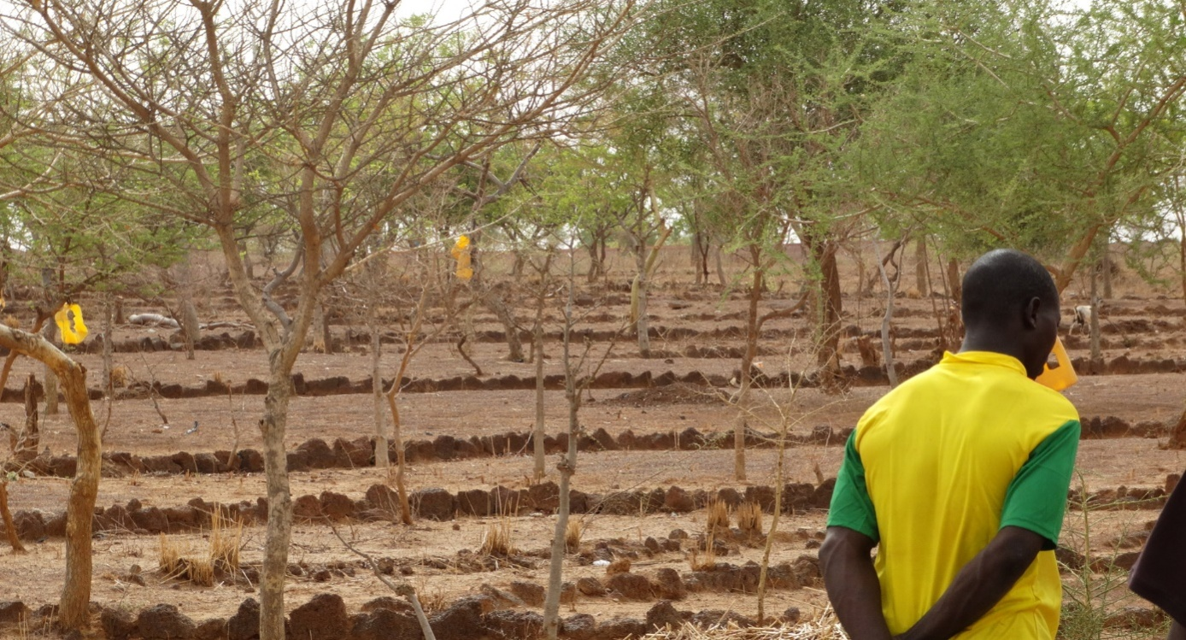

Example of regreening in Burkina Faso with rock bunds and FMNR

1. **We urge the governments of the Sahelian countries and all countries with significant areas of drylands to step up their actions on the restoration of degraded lands and regreening, by making long term and sustainable financial investments for this work, through their annual budgets across various ministries.** In addition, more funds need to be allocated to support local integrated development plans designed with Strategic Environmental Assessments.
2. **We urge the governments of the Sahelian countries and across Africa to review their commitments to the Malabo Declaration to achieve Zero Hunger by 2030 by investing 10% of their annual budgets to agriculture. The evidence presented at this conference clearly indicates the funds currently used for agriculture urgently needs to be re-allocated to support regreening by small holder farmers and pastoralists**. This requires significant reform of current agricultural development policies, including the management of fertilizer subsidies to create incentives for adopting agroecological farming and land restoration practices. It is essential to adopt the integrated soil fertility management approach, which combines organic and inorganic fertilizers. It also requires changing key extension messages and adapting technical training to better promote regreening practices.
3. **Without such support, millions of small holder farmers and pastoralists will not be able to adapt to irregular rainfall, drought and high temperatures caused by climate change.** Without such support, existing farming systems will continue to be characterized by declining soil fertility, loss of vegetative cover, soil erosion, land degradation, and increasing food, feed, and nutrition insecurity.



Millions of farmers in Niger, Mali and Senegal are protecting and managing the natural regeneration of trees on cropland and increasing the density of trees on their farms and across the agricultural landscape.

1. **We affirm the importance of deepening our understanding of the key drivers and impacts** of the widespread adoption and scaling out of FMNR, agroecological farming and other regreening management practices. We note that FMNR in particular has given many rural communities a compelling reason to organize, negotiate and set local dryland restoration management regulations and plans.
2. **The conference recommends a substantial increase in support for adaptive research undertaken with small holder farmers and pastoralists, strengthened monitoring and evaluation of agroecological farming and natural resource management solutions, and better use of remote sensing.** Successful scaling requires filling gaps in our knowledge, tracking the impacts, and improving the effectiveness of investments to scale-up land restoration and associated regreening initiatives.
3. **We recognize that land degradation exacerbates the effects of climate change,** and that it is also accelerated by climate change. We noted that the rehabilitation of degraded land by regreening practices can be both a climate adaptation and resilience measure and a climate mitigation measure for the Sahel.
4. **We noted that pastoral livestock systems are a source of livelihood for many families in the Sahel. Mobile rotational grazing is important for holistic management** of pastures and range lands.
5. **The conference participants are deeply convinced that regreening, including agroecology, holistic grazing management on rangelands, and land restoration must become part of effective peace-building and security in the Sahel.** Regreening is a critical element in resolving conflicts by providing livestock herders with secure access rights to their traditional pastures, and restoring these lands in a scalable way, while also enabling sustainable intensification of agriculture by smallholder farmers.

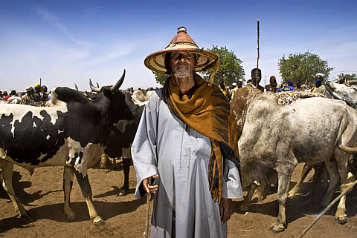

Pastoral herder with his livestock. Mobile pastoralists are key actors in regreening range lands.

1. **The conference recognizes that women and youth are the largest groups that are dependent on agriculture and pastoralism** – and yet they are the least empowered and supported. All initiatives to scale up regreening must give priority attention to engaging and providing benefits to these often marginalized groups.
2. **Success in regreening depends on empowering women to have a voice in decisionmaking, and enabling them to secure access productive resources, particularly land.** It also depends on motivating women by ensuring they benefit directly from FMNR, agroecology and land restoration innovations, not only from family and community land, but also on their own fields. If half of the rural population, **women,** are by-passed by training and support, and if they do not directly benefit from regreening, scaling efforts will founder.
3. **The conference also recognizes that youth compose over 60% of the population of the Sahel. Their involvement is absolutely crucial for the success of regreening.** If the youth are not enabled to see that their futures are closely tied to sustainable management of natural resources; if the youth are not deeply involved in the design and decisionmaking in their communities; and if the youth do not benefit directly from regreening practices, scaling out initiatives will ultimately fail.
4. **We believe that rural communities should drive regreening initiatives. We urge government and development partners to place rural communities at the centre of all scaling initiatives.**Governmental and NGO assistance should be informed by a local decision-making framework in order to make the suite of complementary, improved land and water management practices relevant to local culture, laws, climate, soils, cropping and grazing systems.
5. **This community-led process can be reinforced through awareness raising, mobilization, and strengthening of individual and organizational capacities to lead efforts to transform their lands, thus achieving a critical mass of practice for regreening in each agricultural or pastoral context.**  **We noted the important roles that traditional leadership plays**in through local governance and enforcement of bylaws related to natural resource management, including land and water.
6. **This will require provisions for mobilizing local community resources.** During the conference, participants presented many examples. These included fostering local women’s savings and credit groups, developing value chains for nontimber forest products, training a mass of local volunteers to promote FMNR and agroecological innovations, engaging youth for improved stewardship of each community’s natural resources, and enforcing community bylaws to preventing bush fires and over-cutting of trees.
7. **We recognize that the drive and dynamism of the private sector is crucial for success. The largest group in the private sector are the smallholder farmers and pastoralists themselves.** It is essential to helpthem earn income through improved marketing for their crops, tree products and livestock, This will enable them to beat famine, reduce malnutrition, and escape from poverty. Innovative business models built on better soil management, logistics, extension, pricing, quality control and marketing are already found in the Sahel and across Africa, and should be supported.
8. **Existing efforts in the private sector must grow and become better known, so as to inspire other business actors, including micro-credit institutions, to support and benefit from regreening.** Policymakers and their donor partners must do more to encourage and engage the private sector through appropriate incentives.
9. **We recommend that rural advisory services** should evolve their attitudes, develop their awareness of the vital paradigm shift to regreening and strengthen their institutional capacity to enable smallholder farm families to adapt the principles of agroecology, and in particular agroforestry approaches such as FMNR, to their specific conditions, and to encourage the application of regreening practices.
10. **Scaling out regreening initiatives requires highly context-specific and decentralized action. This requires providing additional resources to local governments.** It also depends on strengthening their institutional capacity for developing and coordinating context-specific plans for regreening in close collaboration with rural communities and pastoralists.
11. **We note that governments must undertake reforms to ensure policies secure and protect the rights of communities and individuals to their lands.** This includes supporting formulation of community-based land use plans and bylaws; ensuring that land users, including rural women, youth and pastoralists, have secure land tenure and exclusive rights to manage and sustainably exploit trees, and other natural resources, on their land.
12. **The conference urges each government to review its policies and legislation to improve the enabling conditions for local investment in agroforestry, FMNR, alternative energy, agroecology, conservation farming, rotating mobile grazing, land restoration, and sustainable natural resource management,** and to rationalize food and agriculture policies to avoid perverse incentives that discourage widespread adoption of such practices.
13. **We have agreed that the outcomes of this conference will be shared with the African Union, ECOWAS, CILSS, and that the recommendations be acted upon by all governments in the Sahel, with the support of inter-governmental and technical and financial donor agencies.**
14. **We, the conference participants, are jointly committed** to sustaining the momentum in accelerating the scaling-up of land restoration that was generated during this conference, **by moving to fully implement the action plans that we jointly developed.**
15. **This includes developing close coordination with related inter-state initiatives such as the Great Green Wall of the Sahara and the Sahel, the African Forest Landscape Restoration initiative (AFR100), and the United Nations Convention to Combat Desertification’s goal of land degradation neutrality.** We are convinced that these initiatives are vital to achieve the Sustainable Development Goals, national climate change adaptation plans, and the Nationally Determined Contributions from the Paris Climate Accord, and the African Union’s 2nd Africa Drylands Conference recommendation on FMNR.
16. **We therefore propose to create a Sahelian EverGreening Platform** to bring together committed leaders from the many non governmental organizations and government entities for the purpose of mobilizing their combined strengths for massive scaling-up of evergreening for land restoration in the Sahel.

1. **The purpose of this platform will be to encourage commitments and coordinated action by all stakeholders** in the Sahel, and in West Africa for land restoration and sustainable management, **in line with the vigorous action plans generated at the conference**. **And to cascade these targets down to sub-national level to fully engage local governments and communities in creating national evergreening movements in every country**.
2. **We thank the Government of Mali for hosting the Conference, and the many donors and partner organizations** that came together to make this historic event possible; and express our gratitude to World Vision, The World Agroforestry Center (ICRAF), The Global EverGreening Alliance and the Food and Agriculture Organization of the UN (FAO) for their leadership in organizing the meeting. We look forward to working together to sustain the momentum generated by this Conference to achieve the aspirations that have been laid down in this Declaration.

**28 February 2019 Bamako, Mali**